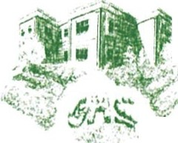
Griswold High School
·... 267 Slater Avenue
.- Griswold, CT 06351
Phone (860) 376-7640 Fax (860) 376-7684
griswoldpublicschools.org
Erin Palonen, Principal Marceline Macrino, Associate Principal

Dear Parents/guardians:

It’s hard to believe, but in just a few short months, your student’s stay at Griswold High School will be nothing more than a memory. You know your child is amazing – why not show them that in this year’s yearbook? You have the opportunity to let them know how proud of them you are. Your recognition ad will be printed and remembered forever! By purchasing a space you can tell them how special they are with your own pictures and in your own words.

Making your ad is simple. Just make an appointment with Mr. Schoen. Come to the appointment with pictures and a rough draft of the words to be used in the graduation ad. To make an appointment please email Mr. Schoen at gschoen@griswoldpublicschools.org. Due to yearbook printing deadlines, graduation ads must be completed by March 31st. With graduation approaching March 31st will be here before you know it. Please set up an appointment as soon as possible. Payment plans are available.

June will be here before you know it. Cherish these moments, graduation day will be here soon!

Sincerely,

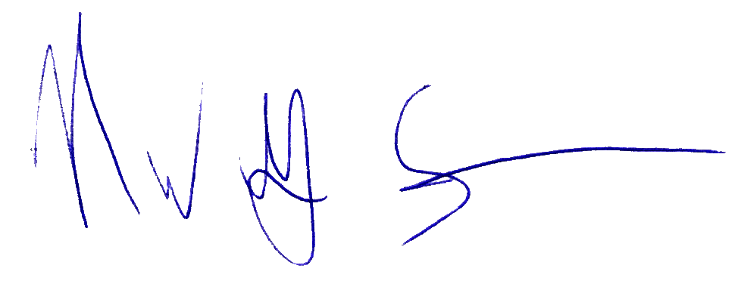
Greg Schoen
Griswold High School
Business Department
Yearbook Advisor
GHS Cross Country/GMS Track/GMS Girls Basketball Coach
gschoen@griswoldpublicschools.org

Prices:
Full page (8 ½”x 11”) $ 350 - 1-8 pictures 300 Words
½ page (8 ½” x 5 ½”) $ 190 - 1-5 pictures 200 Words
¼ page (4 ¼” x 5 ½”) $ 120 - 1- 3 pictures 100 Words
1/8 page (2” x 3”) $ 90 - 1- 2 pictures 100 Words
Yearbook $ 87 (www.jostens.com)

Payment plans for graduation ads are available.

FAQ’s:
Do my photos have to be the same size?
No. We have the ability to scan and resize photos as needed.
Do I have to have the exact number of words specified?
No. It is a suggested amount that you stay around that number in order to keep text legible. The number of photos may also affect the word count.
Do I have to type my text?
No. You may handwrite your text, however, typing the text and sending it to Mr. Schoen in advance can speed up the creating process during the appointment.
Can I submit digital photos?
Yes. You may submit them on disc with this form. Digital files do need to be at a resolution of at least 300 dpi, though, otherwise they will not be useable for yearbook publishing. When scanning photos, most scanning programs have a “custom” section where you can change your resolution to at least 300.
If the yearbook doesn’t come out until the end of the year, why do I need to submit this so early?
The yearbook is created all throughout the year. Many schools need to get pages in as early as October and need your ads to help them reach that goal.
Will I receive my photos back?
Yes. Your photos will be kept in a safe place until your ad is created. Your yearbook advisor will then have them available for pick up at the end of the year.
Who do I ask if I have questions about yearbook?
If you have any questions regarding yearbook please contact Mr. Schoen at gschoen@griswoldpublicschools.org

